Lightweight Feedback Compressor
Version 1.0.1

Welcome
Thank you for downloading this fine plug-in. Lightweight Feedback Compressor is a dynamic processor VST plugin optimized for low CPU usage maintaining the highest precision in signal processing. With a free adjustable knee [in dB] it is unique in this class.

In contrast to the Lightweight Compressor plugin, this plugin uses a feedback topology resulting in a slightly different sound.

In order to get the most out of the Lightweight Feedback Compressor, please spend a few moments reading this brief manual.

License
The pre-compiled Lightweight Feedback Compressor has a very simple license:

- Lightweight Feedback Compressor is freeware. This means that you are free to distribute it, give it to friends, or otherwise share it around. However, only the entire unaltered archive, including this document, may be re-distributed.
- Copyright of the code and the finished plug-in remain the property of the Delphi ASIO & VST Project and namely Christian-W. Budde.
- This plug-in is provided at no cost; therefore the author Christian-W. Budde assume no responsibility for any negative effects that may occur to the end user or the equipment used to run the plug-in.
- Magazine editors are welcome to include the plug-in on cover mount discs or similar media; however, I request that am informed about it via e-mail. A few copies of the publication are always appreciated, but not expected.

User Interface
The user interface shows all adjustable parameters and a readout for the characteristic curve. There are no meters available to maintain the lowest possible CPU usage without wasting too much CPU cycles. Either a dedicated analyse plugin or the build in meters can be used for this task.
Here is a commented screenshot:
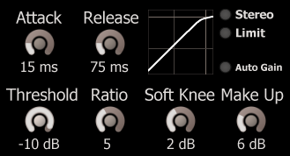
Release Time
(50 µs* - 5 s)
Attack Time
(10 µs* - 1 s)
Characteristic Curve Plot
Switches
- Independent Stereo Processing
- Soft Clip Limiting

Automatic Make-Up Gain

Make-Up Gain
(0 dB – 60 dB)
Threshold
(-90 dB - +10 dB)
Comp. Ratio
(1:1 – 100:1)
Soft Knee
(0 dB – 10 dB)

(* lowest time bounds depend on the samplerate and thus might differ)
The dials can be adjusted by clicking and dragging up and down on a dial. To reset the dials to their defaults hold the [Ctrl] key while clicking on the dial. Holding the [Shift] key enters the fine tune mode.
Below any dial a read out shows the exact value of a parameter.
The switches can be toggled by simply clicking the LED or the text.
NOTE: When the plugin is in 'Auto Gain' mode it is not possible to manually adjust the make up gain.

The parameters
This plugin features nine adjustable parameters in three categories. The categories are 'Time Constants' containing the 'Attack' and 'Release' parameter, 'Characteristic' containing 'Threshold', 'Ratio', 'Soft Knee' and 'Make Up' and the last category 'Mode' contains the switches 'Auto Gain', 'Stereo', 'Limit' and the yet unexposed 'Mix'.

Time Constants
The time constants control the detector stage. The attack and release times are responsible for how fast the compressor reacts and how long it takes to recover.

Attack Time
The attack time controls the duration until the compressor reaches 50% of the level determined by the ratio. Internally it is implemented as a simple envelope follower based on a first order filter with a very low frequency (tuned by the attack time). Compared to other manufacturers this time may differ, so take care while comparing this compressor with other compressors.

Release Time
The release time controls the duration until the compressor recovers if the input falls below the threshold. It is implemented identical to the attack stage (see above).

NOTE: The lowest time bounds depend on the samplerate. The reason for this is that in a digital system the shortest possible delay for a feedback is one sample. To avoid quantization problems the user should take care not to choose too short times. If short times are desired it is recommended to use the (feed forward) compressor.

Characteristic
The characteristic curve (as directly shown on the GUI) can be controlled independently by 4 dedicated parameters.

Threshold
The threshold is the level above which compression takes place.
A high value (e.g. -5 dB) means that there is hardly any compression, while a low setting (e.g. -60 dB) means that the signal is nearly compressed all the time.

Ratio
The ratio determines the input/output ratio for signals above the threshold. In this plugin the ratio can be adjusted between 1:1 to 100:1. For example, if the signal is 6 dB above the threshold it will be reduced to only 1 dB above the threshold in case of a 6:1 ratio setting.
If only limiting (ratio of ∞:1) is needed, a special limiter plugin is available in the same series.

Soft Knee
Around the threshold it is sometimes desired to have a slow transition towards the selected ratio. In case of a value above 0 dB the ratio slowly increases if the level increases. Especially for higher ratios the audible change from uncompressed to compressed can be reduced.
The soft knee parameter in dB is the margin below the given threshold. This usually results in a lower level compared to a rather hard knee. This holds especially if the input signal is around the threshold. Keep this in mind when comparing hard vs. soft knee.
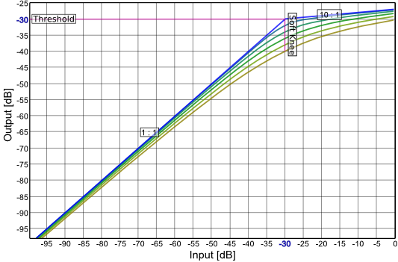

Characteristic Curve Plot

Make Up Gain
To compensate the reduced level, the output level can be adjusted. This gain is called 'Make Up Gain'.
NOTE: Keep in mind that it is not possible to adjust the gain manually if 'Auto Gain' is switched on.

Mode
In the category 'Mode' several miscellaneous switches can be found. Also the yet unused 'Mix' parameter can be found here.

Stereo
If switched of the compressor uses a combined mono signal (L + R) to detect the peak level. The compressor gain will then be applied independently to the left and right channel.
If switched on two independent compressors are used. In this operation mode the CPU will nearly double and in case of a true stereo input the stereo imaging will probably suffer from phase effects.
NOTE: It is recommended to only switch this mode on, when necessary. Otherwise CPU cycles will be wasted for a worse sound.

Limit (Soft Clip)
To ensure the signal stays within its bounds a simple waveshaper is used. The function used here is an approximated hyperbolic tangents.
NOTE: This kind of limiting will add a significant amount of harmonic distortion, since transients can not be passed through uncompressed as without it. Furthermore it is not oversampled which might lead to alias.

Automatic Make-Up Gain ('Auto Gain')
As explained above a deep compression will result in a reduced overall gain, which has to be adjusted by the make-up gain. However, while tweaking it is sometimes desirable to keep the upper part of the curve constant (rather than the lower part). The automatic make-up gain switch ensures that the level always equals at 0 dB.
NOTE: Keep in mind that it is not possible to adjust the make-up gain manually if this is switched on.

Feedback / Bug Reports
I am always eager to hear feedback or have bugs reported. The easiest
way is to send me a mail to: Christian@aixcoustic.com

Furthermore feel free to download the source code, that can be found in the Delphi ASIO & VST Project at sourceforge.net.

Version History
  - First release!
1.0.1 Optimizations, Manual added
1.0.2 Renamed 'Fast' to 'Lightweight'

Credits

• Programming: Christian W. Budde
• Additional Framework Programming: Tobias Fleischer, Maik Menz
• Special Thanks: Swen Müller, Duncan Parsons, Laurent de Soras
• Documentation based on a template by Greg Pettit

VST name and technology © Steinberg GmbH
The VST logo is a trademark of Steinberg GmbH

